**Ideation Phase**

**Define the Problem Statements**

|  |  |
| --- | --- |
| Date | 19 September 2022 |
| Team ID | PNT2022TMID31406 |
| Project Name | Project - AI - Based localisation and classification of skin disease with Erythema |
| Maximum Marks | 2 Marks |

**Customer Problem Statement Template:**

Create a problem statement to understand your customer's point of view. The Customer Problem Statement template helps you focus on what matters to create experiences people will love.

A well-articulated customer problem statement allows you and your team to find the ideal solution for the challenges your customers face. Throughout the process, you’ll also be able to empathize with your customers, which helps you better understand how they perceive your product or service.

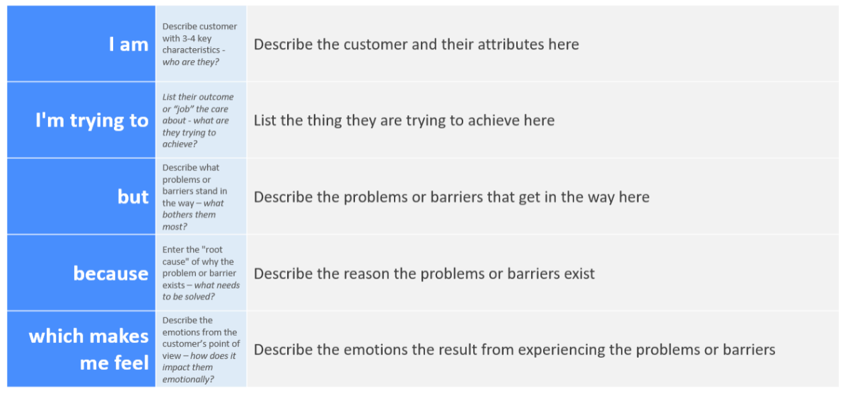

Reference: <https://miro.com/templates/customer-problem-statement/>

**Example:**

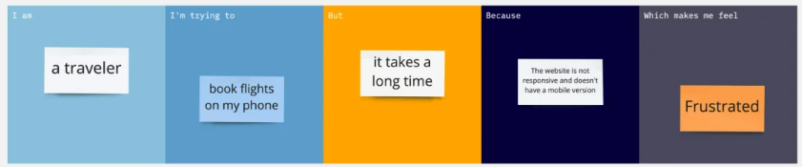

|  |  |  |  |  |  |
| --- | --- | --- | --- | --- | --- |
| **Problem Statement (PS)** | **I am (Customer)** | **I’m trying to** | **But** | **Because** | **Which makes me feel** |
| PS-1 | Those feel worried about any symtoms Of their skin disease | Make a Open web application for Detecting Skin Disease | The Virtual Accuracy in mobile phone is not well as test in Hospital | The Data need to be collected from various platform and more accurate algorithm need to be used | Most probably the Humans rather go to Hospital for initial check up. They will visit Hospital at the end stage is not Good for Health. |
| PS-2 | Those Person already affected by Skin disease taking treatment need to check their Improvement | The affected person check randomly whether our treatment improves their life or not ? by without going to Hospital | The Result maybe not accurate as the Test result Provided by Doctors | Sometime the website will show the accurate result. But in somecase the application may make any error | So inorder to overcome the error in result, More proper and More accurate algorithm is need to be selected and used.More accurate result will automatically attract the User (Affected/Non-Affected Person) |